Names _________________________________________ Date _____________________ Period ________
Reasons for the Seasons webquest worksheet
(Google – reasons for the seasons webquest. Click the first link)
Misconceptions about the reasons for the seasons
What are misconceptions? A misconception is an incorrect idea about something. Your task is to find some common misconceptions about the reasons for the seasons. Record them in the table below. You will be using this information to make your first poster.
1.
2.
3.
4
Tilt of the Earth
How does the Earth’s tilt affect the seasons? Research your websites. Write your information below. In the box below, draw a picture showing how the tilt of the earth affects the seasons. Draw a picture of the Earth, showing its tilt, at each season. Label the North and South poles.
Winter | Spring
Summer | Fall/Autumn
Earth’s Location and Seasons
The Earth is at four different points in its orbit around the sun when we have each season. Where is the earth when it is summer (or winter, fall and spring) in the Northern Hemisphere? Does the Earth tilt towards or away from the sun? Research your websites. Draw a picture of the Earth revolving around the sun through the year. Show the earth at its location during Winter, Spring, Summer and Fall/Autumn in the Northern Hemisphere. Label the North and South Poles on each of your Earths.
What’s your angle?
How does the angle of the sunlight that hits the Earth affect the seasons? Research your websites. Draw pictures showing how the angle of sunlight determines whether the season is warm or cold.
Winter | Spring
Summer | Fall/Autumn

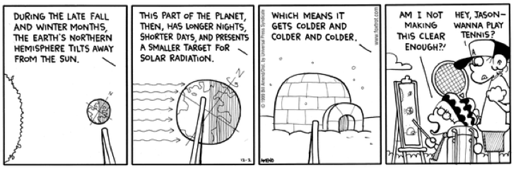

Making the Reason for the Seasons Posters
Your webquest task is to make four posters. The posters will explain:
- Misconceptions about the reasons for the seasons
- Tilt of the Earth
- Earth location and seasons
- How the angle of heat energy from the sun hitting the Earth affects heat during the seasons

Poster Requirements:
- Posters will be drawn on four sheets of white paper
- Diagrams and drawing will be used on every poster to help illustrate the concepts
- Colored pencils and/or crayons will be used for illustrations
- The explanations are written neatly and clearly
- The poster will be neat and all information will be easily found

Use your time in the computer lab to research the required information for the four posters. When we return to class, take your time and produce neat and accurate posters explaining the reasons for the seasons.

Names __________________________________________ Date _________________ Period __________

Reason For the Seasons Poster Rubric – this needs to be turned in with your posters

CATEGORY | 4 | 3 | 2 | 1 | Score
Required Elements | The posters includes all required elements as well as additional information. | All required elements are included on the posters. | All but 1 of the required elements are included on the posters. | Several required elements were missing.
Labels | All items of importance on the posters are clearly labeled. | Almost all items of importance on the posters are clearly labeled with labels. | Many items of importance on the posters are clearly labeled. | No important items were labeled.
Graphics - Relevance | All graphics are related to the topic and make it easier to understand. | All graphics are related to the topic and most make it easier to understand. | All graphics relate to the topic. | Graphics do not relate to the topic.
Attractiveness | The posters are exceptionally attractive in terms of design, layout, and neatness. | The posters are attractive in terms of design, layout and neatness. | The posters are acceptably attractive though it may be a bit messy. | The posters are distractingly messy or very poorly designed. It is not attractive.
Grammar | There are no grammatical/ mechanical mistakes on the posters. | There are 1-2 grammatical/ mechanical mistakes on the posters. | There are 3-4 grammatical/ mechanical mistakes on the posters. | There are more than 4 grammatical/ mechanical mistakes on the posters.
 |  |  |  | Total

Names __________________________________________ Date _________________ Period __________

Reason For the Seasons Poster Rubric – this needs to be turned in with your posters

CATEGORY | 4 | 3 | 2 | 1 | Score
Required Elements | The posters includes all required elements as well as additional information. | All required elements are included on the posters. | All but 1 of the required elements are included on the posters. | Several required elements were missing.
Labels | All items of importance on the posters are clearly labeled. | Almost all items of importance on the posters are clearly labeled with labels. | Many items of importance on the posters are clearly labeled. | No important items were labeled.
Graphics - Relevance | All graphics are related to the topic and make it easier to understand. | All graphics are related to the topic and most make it easier to understand. | All graphics relate to the topic. | Graphics do not relate to the topic.
Attractiveness | The posters are exceptionally attractive in terms of design, layout, and neatness. | The posters are attractive in terms of design, layout and neatness. | The posters are acceptably attractive though it may be a bit messy. | The posters are distractingly messy or very poorly designed. It is not attractive.
Grammar | There are no grammatical/ mechanical mistakes on the posters. | There are 1-2 grammatical/ mechanical mistakes on the posters. | There are 3-4 grammatical/ mechanical mistakes on the posters. | There are more than 4 grammatical/ mechanical mistakes on the posters.
 |  |  |  | Total

