Energy Unit Test Review

1. What force causes an object to have potential energy?

2. Kinetic energy is energy of ____________________________.

3. There are two things that affect an object’s kinetic energy. They are m_________ and s_________.

4. Kinetic energy increases as both m_______ and s__________ _______________________________. (increase or decrease)

5. Which one has more kinetic energy, a person walking, a person running, or a person riding a bicycle? Why?

6. If a bowling ball and a soccer ball are both moving at the same speed, which one will have more kinetic energy? Why?

7. If you pick up a grocery bag from the floor and put in on the table, you increase its potential energy. Explain how.

8. Label the pictures below as either Kinetic or Potential energy. Then, explain why.

a. C:\Documents and Settings\iwbakerc\Local Settings\Temporary Internet Files\Content.IE5\X2URN9DS\MC900351569[1].wmf b. C:\Documents and Settings\iwbakerc\Local Settings\Temporary Internet Files\Content.IE5\CE9EJJLW\MC900329618[1].wmf

1. If you wrap a fur coat around a thermometer, will its temperature rise? Explain why or why not.
2. If you hold one end of a metal nail against a piece of ice, the end in your hand soon becomes cold. Does cold flow from the ice to your hand? Or does heat flow from your hand to the ice? Explain.
3. Heat transfer is a slow process, meaning it doesn’t happen very quickly. Explain why

“firewalkers” can walk safely across a bed of red-hot coals in bare feet.

1. If you drop a hot rock into a pail of water, the temperature of the rock and the water will change until both are equal. The rock will cool and the water will warm. Is this true if the rock is dropped into the Atlantic Ocean?
2. When you step out of a swimming pool on a hot, dry day, you feel quite chilly. Why?
3. You have 2 beakers of water. Beaker 1 is at 110°C and Beaker 2 is at 45°C. Which picture correctly shows which way the heat will flow?  
   C:\Documents and Settings\iwbakerc\Local Settings\Temporary Internet Files\Content.IE5\YZL4S0W9\MC900329168[1].wmf C:\Documents and Settings\iwbakerc\Local Settings\Temporary Internet Files\Content.IE5\YZL4S0W9\MC900329168[1].wmf C:\Documents and Settings\iwbakerc\Local Settings\Temporary Internet Files\Content.IE5\YZL4S0W9\MC900329168[1].wmf C:\Documents and Settings\iwbakerc\Local Settings\Temporary Internet Files\Content.IE5\YZL4S0W9\MC900329168[1].wmf  
   1. 95®C 2. 45®C 1. 95® C 2. 45®C

1. Next to each example, tell what kind of heat transfer is taking place:  
   a. 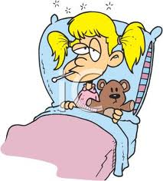 b. 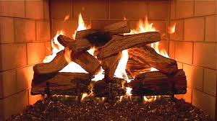 c 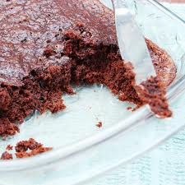.

d. 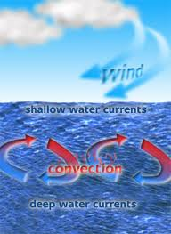 e.  f. 