1. Select article or video.
2. Select the details tab

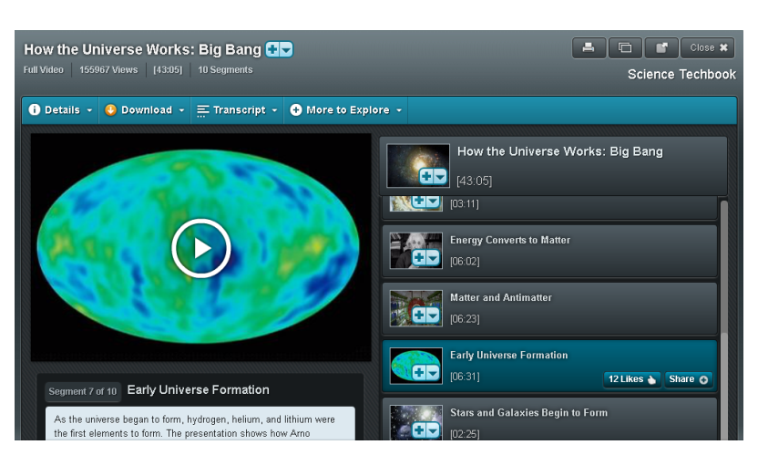

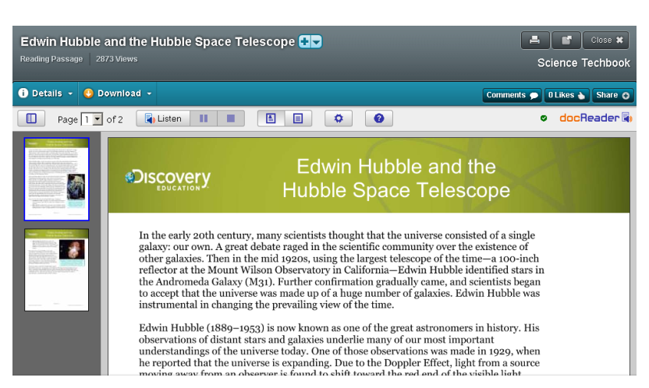

1. Use complete APA style citation in bibliography.
2. Use the first words and the year in the text.

